Clear Liquid Items OK
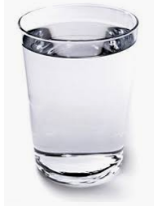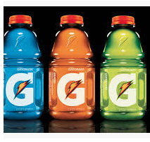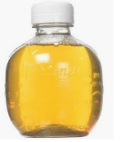
OK Water OK Clear sports drinks w/ electrolytes OK Apple Juice
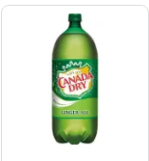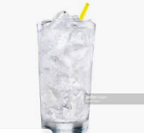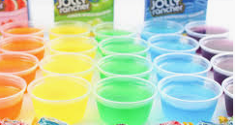
OK Ginger Ale OK Clear Soda OK Flavored Gelatin (no red or purple)
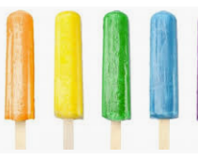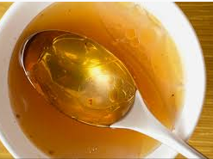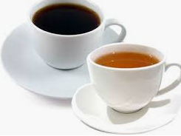
OK Popsicles OK Clear Broth OK Black Coffee or Tea (no cream)
*NO purple or red colored liquid.
*NO alcohol

