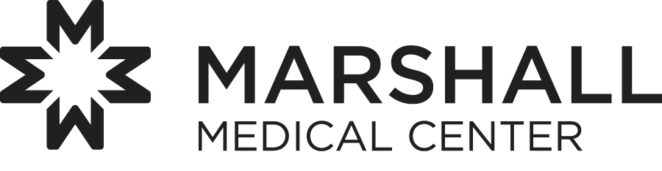

Community Relations / Sponsorship Guidelines
(updated 12/13/2016)

Since 1959, Marshall Medical Center has supported healthcare, social service and civic organizations on the western slope of El Dorado County through charitable contributions and sponsorships. Marshall Medical Center has an ongoing commitment to help others in their work to improve the quality of life in our community.

Outlined below you will find information about Marshall Medical Center’s Community Relations and Sponsorship Guidelines, including eligibility guidelines for giving, areas of interest and the procedures for applying for a sponsorship.

Eligibility Guidelines

Marshall Medical Center’s Community Outreach Program provides support to organizations within El Dorado County. When applying for a contribution or sponsorship, you must meet the conditions that guide our organization’s outreach program.

- Applicants must be a charitable organization. An organization qualifies as charitable if it has received a 501(c)(3) designation from the Internal Revenue Service or if it is a public school, school district or municipal agency providing health, education, or community services.
- To be eligible for funding, your organization must provide service in El Dorado County and/or your event must be held in El Dorado County.
- Organizations and programs must provide measurable outreach services in the community and complement Marshall Medical Center’s mission.
- The intent and goal of our outreach program is to encourage and enable organizations to collaborate with Marshall Medical Center, improving the health status and quality of life of the residents in our communities.
- Organizations must be capable of administering the project’s funds.
- No open-ended funding arrangements will be made; contributions and sponsorships will be made for a defined event or specific time period.

Priorities
Healthcare
Healthcare programs designed to improve the health and education of our community is our greatest priority. Our primary focus, when reviewing applications, will be on the proposal’s ability to address the following defined community needs:
- Access to health screening and prevention education
- Services to the under-served populations within our community (economically poor; women and children; mentally or physically disabled; or other disenfranchised populations)
- Reducing and preventing family violence
- Education regarding accident prevention.

Education
Education is a broad area of importance to Marshall Medical Center. Our primary interest in education is community health programs designed to improve the health status of the residents in our community.

Community Service
Marshall Medical Center provides funding to organizations with an emphasis in using volunteer activities as an element of their community outreach program.

How to Apply
- Provide a clear description of the project and the proposed level of support.
- Define the population being served.
- Identify the area of focus in which you are applying (e.g., healthcare, education, or community service).
- Provide a brief description of your organization, its mission and history.
- Provide a current mailing address, telephone number and the name of a contact.
- Provide an overview of how the proceeds from the event/program will be distributed.
- Sponsorship only – Provide a detailed description of the event/program and the organization hosting it, as well as a description of the role of potential sponsors, including a list of all responsibilities of and benefits to Marshall Medical Center.

Deadlines and Funding Dates
It is recommended that applications be submitted at least 60 calendar days prior to the program or event. Once received, applications will be internally evaluated. For those that are accepted, funding will be provided with 60 days of receipt.

Recipient Responsibilities
- Use of Marshall Medical Center’s name in press releases must be pre-approved.
- Usage of the Marshall Medical Center logo must be pre-approved.

Contact Information
Marshall Medical Center
Attention: Marcella Fox
Marketing and Community Relations Department
1100 Marshall Way
Placerville, CA 95667
mfox@marshallmedical.org

